**Programming Fundamentals**



|  |  |
| --- | --- |
| Name | Ali Salman |
| Registration Number | FA22-BCE-005 |
| Class | BCE- 2A |
| Instructor’s Name | Dr. Omar Ahmed |

***Lab # 02***

***Basic Steps for Algorithm Development and Piece-Wise Functions using if/else Statement***

**In Lab:**

**Task 1:** Develop an Algorithm.



**Algorithm:**

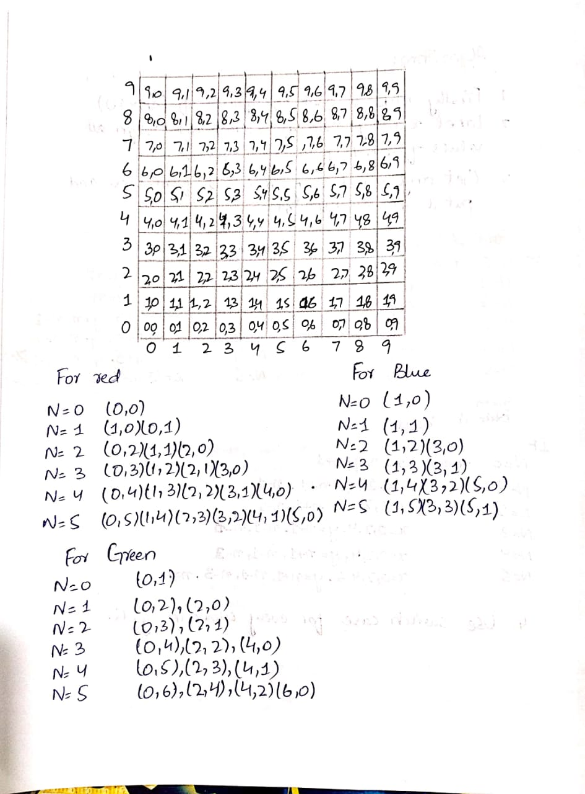

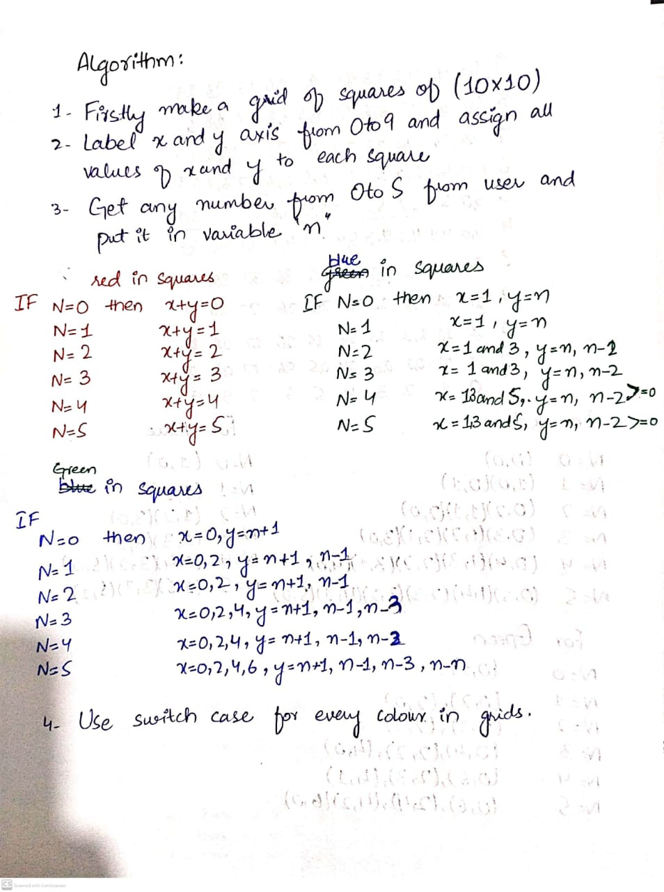

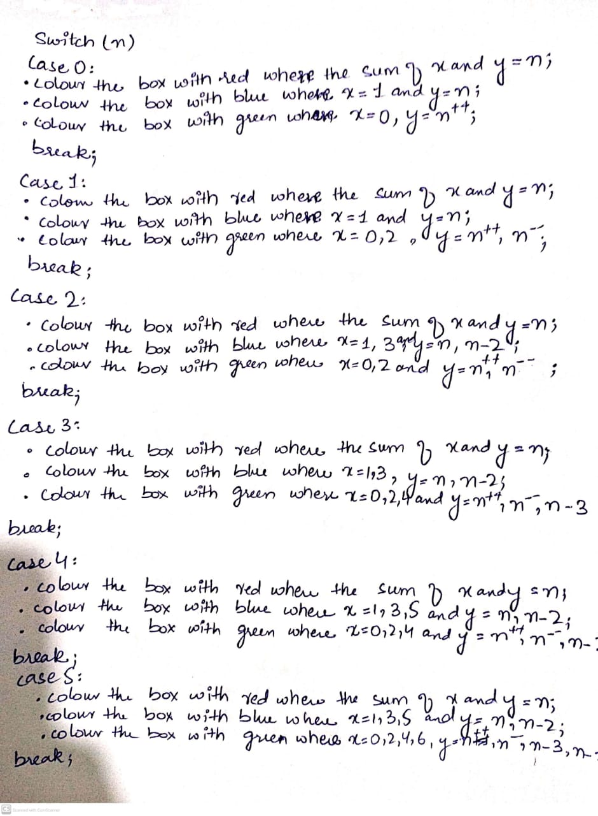

**Task 2:** Write a C Program to Implement a Piecewise Function.

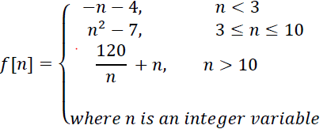

**Program:**

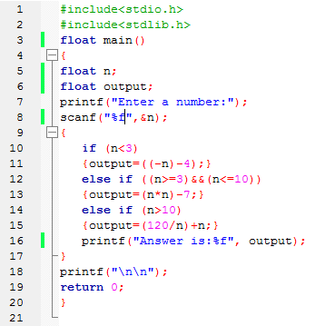

* Some answers of 3rd piece wise are in decimal value, so we use floating format specifiers and escape sequences.

**Outputs:**

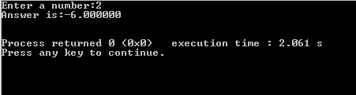

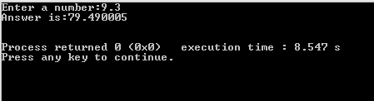

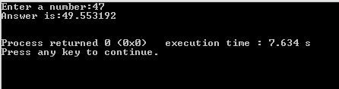

**Post Lab Task:**

Write a program that takes integer input from user and tells (displays on the output console screen) whether it is even or odd.

**Program code:**

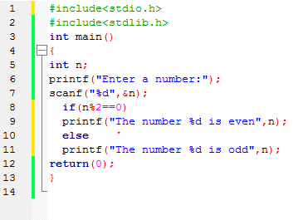

**Output:**

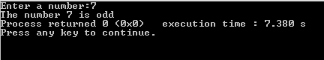

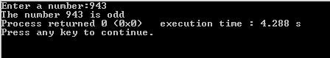

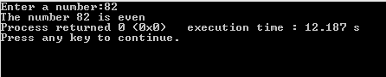

***Critical Analysis:***

* We learn the functioning of if/else statement.
* We understand the working of 4 step process of algorithm development.
* We learn to generate logic of different patterns or grids.